27-7 Yahrzeit Panels

The Yahrzeit Panels are etched glass panels with an automated lighting mechanism. These panels memorialize the names and dates of death of members of the congregation or their families.

Manufacturer: On-Site Systems Inc. http://www.on-sitesystems.com
Yyz Systems Inc http://www.yyzsystems.com

Model Number: custom

Maintenance: Clean the glass monthly, with Windex wipes or equivalent

Service: Glass – On-Site Systems
Electronics – Yyz Systems
Software – Allan Schwartz
Repair/reprint panels of glass – On-Site Systems

Location: Sanctuary west wall

Installers: On-Site Systems Inc. http://www.on-sitesystems.com
Gary Taylor gary@on-sitesystems.com 800-838-7778
Yyz Systems Inc http://www.yyzsystems.com
Marko Hajdinovic marko@yyzsystems.com 905-795-8500
Allan Schwartz allanschwartz@sbcglobal.net 408-829-8046

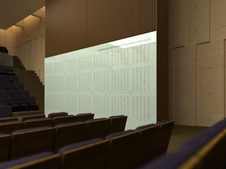

This document doesn’t discuss the software, see section 27-8 Yahrzeit Server. A broader overview of the Yahrzeit Wall can be found in section 27-6 Yahrzeit Wall Overview.


PROCEDURE: How-To Create and/or Modify A Yahrzeit Panel

It is advisable to create and/or modify one, two or three panels at one time – because we own three spare panels, and we have a shipping crate that holds exactly three panels.

Step 1: Advertise. via email or mailings to the congregation 4 months prior to the target installation, timed for a particular Yizkor observance, in order to capture the needed information in an efficient and timely manner.

It is most efficient to batch entries, additions and any necessary changes or corrections. This process has proven to be complex. In an effort to streamline this process, follow these recommendations:

Step 2: Sales. Collect ACCURATE and CENTRALIZED data for new additions (names of decreased, Hebrew and English date(s) of death, etc) and any changes or corrections to existing entries. Information should be collected on a form, then transferred to a spreadsheet with the following columns:

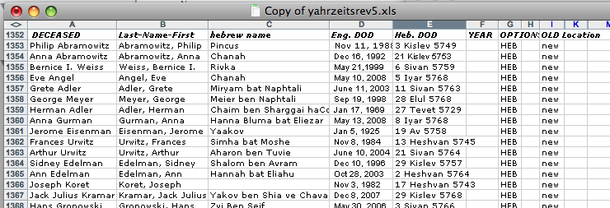

Step 3: Based on the number of the additional names, the designer will decide where the changes will go and which panel(s) will be modified.

Step 4: Record.
Update the spreadsheet with the purchased names, then sort (each panel is alphabetized) and add the panel locations. This is column K in the above illustration, blank at time Step 2 is done, utilized at this time.

Step 5: Update Illustrator files

Step 6: Review process involving congregants
Send email to each congregant who has purchased a name. The email should show a view of the panel and reflect the new addition or any changes. The most effective way to do this is to take a Screen Snapshot with Illustrator running, then crop so it so that a relatively small .PNG file is saved. Email just that small .PNG file to the congregant. For example:

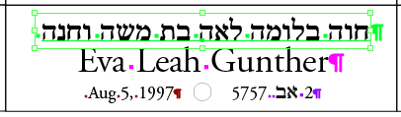

Mailing the multi-megabyte .PDF file seemed to be problematic with more than half of the last set of congregants, but everyone should be able to receive an embedded .PNG image in an email. Allow each congregant to reply back with satisfaction or corrections, but impose a deadline. Sometimes, the congregant may have come into the office to view the paper copy, or show you a photo of the gravestone.

Print a proof copy of the finished panel (on 33.5” x 33.5” sheet of paper or vellum), and proof the corrections carefully. Tape this sheet up over the actual glass panel to be reprinted. Notify the congregation that on the upcoming Shabbat all may view a proof of the panel.

Corrections should be captured on another form, and previous documentation, i.e., the form, email, or photos of gravestones should be attached. Source documents such as these forms, emails, etc. should be carefully organized in a binder.

Step 7 / Step 8 / Step 9 / Step 10
Repeat “Record” and “Review Process” two additional times and proofread every single entry.

Step 11: Ship spare pieces of glass to On-Site
Our 3 spare pieces of glass are already packed in a crate, and the crate is currently in the large closet in Koret Hall.

Step 12: Production. Finalize files including vectorize all text, and produce PDF. Email PDF and illustrator files to On-Site .

Step 13: The yahrzeit database which the Yahrzeit Server uses needs to be updated to include all the new records. Test the yahrzeit server lights behind the new names in both yahrzeit-mode and yizkor-mode.

Step 14: On-Site Systems has their own production schedule for printing the glass. This takes approximately three weeks.

Step 15: On-Site Systems will ship the crate with the three new pieces of glass back to CBS.

Step 16: Installation. Receive new glass panels from OnSite
They will come back in the same crate. Install new pieces of glass. Call in a vendor (Allan Schwartz or someone with glass-handling experience) to swap the old panels of glass with the newly-printed panels of glass.
The old panels of glass then become our spare pieces and should be packed for shipment in the crate. The crate is stored in the Koret Hall closet, ready for the next cycle.

Step 17: Completion.
Announce the new Yahrzeit Panels in HaRuach and/or HaLuach; email all congregants who purchased a name. Re-test the yahrzeit server lights behind the new names in both yahrzeit-mode and yizkor-mode.

How long does this process take and how do we plan for the next cycle?

Duration Aug/2008 Pesach next H.H.

ADVERTISE: 1 wk May 16 jan May & June

SALES: 8 wks june&july now–Feb 17 May & June
Collect 8 wks june 1–july 31 now–feb 13 May & June
final data to designer 4 days aug 1–aug 4 feb 16–17 june 25–30

REVIEW: 4 wks Aug. Feb. July
1st draft create artwork 4 days aug 4-8 feb 17–20 july 1–3
1st review process 5 days aug 8-13 feb 20–24 july 3–8
2nd draft create artwork 2 days aug 14-15 feb 24–25 july 9–10
2nd review process 5 days aug 15-20 feb 26–mar 2 july 10–15
3rd draft create artwork 2 days aug 21-22 not needed not needed
3rd review 5 days aug 22-27
final draft create artwork 2 days aug 28-29 Mar 2–3 july 16–17
final review 5 days aug 29-sep 3 mar 4–9 july 17–24

PRODUCTION: 4 wks Sep. Mar. Aug.
finalize files, to OSS 1 days sep 4 mar 9 aug 3
fix yahrzeit database 1 wk sep 4-11 mar 9–16 aug 3–10
OSS production schedule 3 wk sep 4-19 mar 9–27 aug 3–21
ship glass back to cbs 1 wk sep 19-23 mar 30 aug 24–28

INSTALLATION: 2 days
receive & install glass 1 day Sep 23 Apr 6 mon aug 31
announce glass is up 1 day Sep 24 Apr 7 tue sep 1
test yahrzeit server 1 day Sep 24 Apr 7 tue sep 1

Although Pesach is a little tough for this year – from the standpoint of creating substantial sales then executing on-time – Shavout (May 30, 2009), is achievable:

Advertise: now
Sales: Feb & Mar
Review: Apr
Production: May
Installation wed. May 27

What are the resource requirements for a staffer and Allan Schwartz to do this work?
The following tables predicts an increase of efficiency over the first (June 2008-Sept 2008) cycle by a factor of 50%. We can do the same work in 50% of the staff time. It also assumes that between 40 and 80 names are either sold or need to be revised.

Duration Aug/2008 Pesach staff Allan
40-80 names
ADVERTISE: 1 wk May 16 jan

SALES: 8 wks june&july now–Feb 17
Collect 8 wks june 1–july 31 now–feb 13 20hr 4hr
final data to designer 4 days aug 1–aug 4 feb 16–17 4hr 4hr

REVIEW: 4 wks Aug. Feb. July
1st draft create artwork 4 days aug 4-8 feb 17–20 2hr 4hr
1st review process 5 days aug 8-13 feb 20–24 8hr
2nd draft create artwork 2 days aug 14-15 feb 24–25 2hr 4hr
2nd review process 5 days aug 15-20 feb 26–mar 2 8hr
3rd draft create artwork 2 days aug 21-22 not needed not needed
3rd review 5 days aug 22-27
final draft create artwork 2 days aug 28-29 Mar 2–3 2hr 4hr
final review 5 days aug 29-sep 3 mar 4–9 8hr 4hr

PRODUCTION: 4 wks Sep. Mar. Aug.
finalize files, to OSS 1 days sep 4 mar 9 4hr
fix yahrzeit database 1 wk sep 4-11 mar 9–16 8hr
OSS production schedule 3 wk sep 4-19 mar 9–27 2hr 4hr
ship glass back to cbs 1 wk sep 19-23 mar 30

INSTALLATION: 2 days
receive & install glass 1 day Sep 23 Apr 6 1hr 4hr
announce glass is up 1 day Sep 24 Apr 7 4hr
test yahrzeit server 1 day Sep 24 Apr 7 4hr

----- -----
10 days 6 days

